Activity Diagram

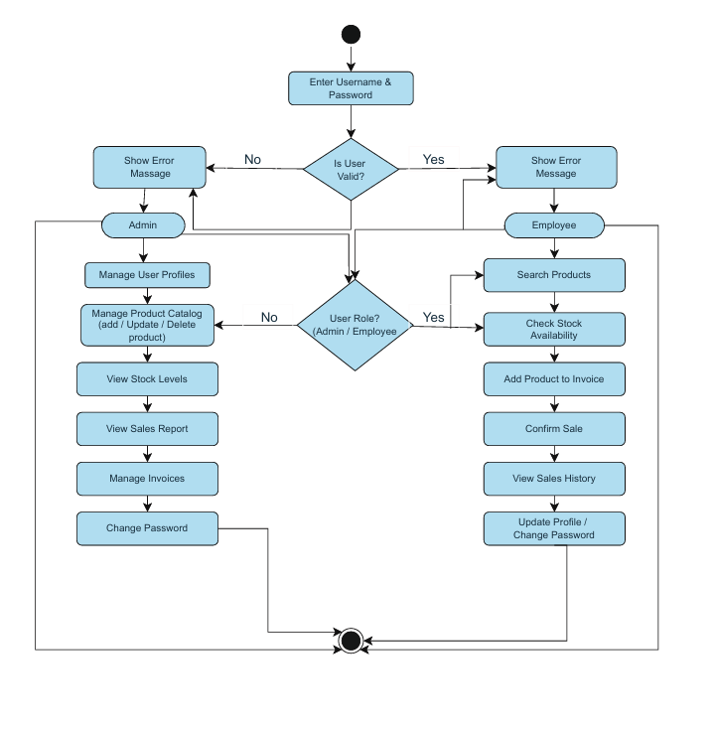

Activity Diagram – Shop Management System
- The Activity Diagram represents the flow of activities in the Shop Management System from start to end.
- The process begins when a user enters login credentials into the system.
- The system validates the credentials and checks whether the user is valid or not.
- If the user is invalid, an error message is displayed and the user is redirected to the login page.
- If the user is valid, the system identifies the user role (Admin or Employee).
- The Admin can manage users, manage products, view stock levels, generate sales reports, manage invoices, and change password.
- The Employee can search products, check stock availability, add products to invoices, confirm sales, view sales history, and update profile information.
- After completing the required actions, the system reaches the final state when the user logs out.

Key Points

- Shows dynamic workflow of the system
- Includes decision nodes for validation and role identification
- Separate activity flows for Admin and Employee
- Clearly defined start and end points

